Hereditary hemorrhagic telangiectasia: a national cohort study using the All of Us database

Kevin Ma BS¹, Jonathan Overdevest MD PhD¹
1Department of Otolaryngology – Head and Neck Surgery, New York-Presbyterian/Columbia University Irving Medical Center, New York, NY, USA

Corresponding Author:
Jonathan Overdevest MD PhD
Department of Otolaryngology – Head and Neck Surgery, New York-Presbyterian/Columbia University Irving Medical Center
180 Fort Washington Ave, New York, NY 10032
jo2566@cumc.columbia.edu

(Keywords)
(Level of Evidence)
Introduction
Hereditary hemorrhagic telangiectasia (HHT), also known as Osler-Weber-Rendu syndrome, is an autosomal dominant vascular disorder caused most commonly by pathogenic variants in ENG or ACVRL1, with a smaller number of cases attributable to SMAD4 or other genes^{1,2}. Diagnosis is typically established using the Curaçao clinical criteria or, increasingly, genetic testing¹.
Estimates of HHT prevalence have historically come from regional studies using pedigree analysis which have generally reported a prevalence of 1 in 5,000 to 1 in 8,000³⁻⁵. Such estimates do not account for underdiagnosed cases or founder mutations, however. The only nationwide estimate of HHT prevalence in the U.S. used a national claims database between 2013 and 2017 and reported prevalence rising from 6.1 to 12.1 per 100,000⁶. Similar increases in reported prevalence have been observed elsewhere and have generally been attributed to improved diagnostic recognition rather than a true rise in disease occurrence⁷.
Recent studies using large genomic databases have placed the true prevalence of HHT to be two to twelve times more prevalent than 1-in-5,000 as is often cited^{8,9}. Consistent with this, the Comprehensive HHT Outcomes Registry of the United States (CHORUS) recently reported that although 57% of its first 600 enrolled patients had developed HHT manifestations by age 13, 63% were not diagnosed until mid-to-late adulthood, underscoring a substantial gap between symptom onset and diagnosis¹⁰.
The present study is the first to combine nationwide scope with electronic medical record (EMR)-level clinical detail to jointly characterize HHT prevalence, incidence, geographic distribution, and age at symptom onset within a single population. The All of Us Research Program, which links longitudinal electronic medical record (EMR) data to survey and genomic data from a large and geographically diverse U.S. cohort, offers an opportunity to address this gap. In this study, we use All of Us data to characterize the prevalence, incidence, geographic distribution, and symptoms of HHT in a large, nationally representative U.S. population.

Methods
This is an observational retrospective cohort study using the Controlled Tier of the All of Us (AoU) Curated Data Repository version 9, which includes adult participants enrolled up to January 1, 2025. All 747,029 participants were included. To account for diagnosis impurity, cases were defined as participants with two or more encounter dates with a Observational Medical Outcomes Partnership (OMOP) diagnosis code of Osler hemorrhagic telangiectasia syndrome (ID 313504), and controls were participants who had never been diagnosed. OMOP codes as well as concepts extracted from clinical notes using natural language processing (NLP) were used to extract symptoms, including epistaxis, iron deficiency or anemia, and gastrointestinal (GI) bleed. Similar methods were used to extract medications (iron supplementation, folic acid, tranexamic acid, and bevacizumab) and procedures (control of epistaxis and GI endoscopy). Three-digit zip codes were collected from participants and used to map their general geographic distribution.
Regarding statistical analysis, two-sided t-tests and Fisher’s exact tests were used to compare continuous and categorical variables, respectively. Benjamini-Hochberg procedure was used to adjust for multiple comparisons when applicable.

Results
Of the 747,029 participants, 260 (0.0003%) carried at least one diagnosis of HHT, or approximately 1 in 2,873. The average age of participants with HHT was 64.1 years (standard deviation [SD] 16.4), significantly older than controls (56.1 years [SD 17.2], p<0.001) (Table 1). Among the participants with HHT, 73.1% (n=119) were female, significantly more than the control group (61.7%, p<0.001), and 69.2% were white (vs 56.0% among controls, p<0.001).

From 2000-2004, the incidence of HHT was 2 people/year; it was 2.4 in 2005-2009, 10.0 in 2010-2014, 19.4 in 2015-2019, and 16.0 in 2020-2024 (the end of data).

All HHT-related symptoms were significantly more common in the HHT group compared to the control group (adjusted p<0.001) (Table 2). Anemia/iron deficiency was the most common symptom, with a prevalence of 66.5% among the HHT cohort versus 20.1% among controls, followed by epistaxis (35.8% vs 2.6%), GI bleeding (30.8% vs 7.7%), pulmonary AVMs, (11.9% vs <0.1%), cerebral AVMs (5.8% vs 0.2%).

Among HHT participants, anemia/iron deficiency was first coded at a median age of 55 years (interquartile range [IQR] 41-66), epistaxis at 55 years (IQR 41-62), GI bleed at 53.5 years (IQR 43-65), pulmonary AVM at 53 years (IQR 43.5-66), and cerebral AVM at 52 years (IQR 42-64.5).

Regarding procedure rates, GI endoscopies (including upper endoscopies and colonoscopies) had been coded in 26.2% of HHT participants, compared to 7.2% of controls. Control of epistaxis (including packing, cautery, or endoscopically) had been performed in 9.2% of HHT participants compared to 0.5% of controls. Embolization of AVMs and other vascular procedures had been performed in <5.5% of HHT participants compared to 0.3% of controls.
Geographically, the states with the most HHT patients were California (14.2%), Alabama (13.8%), Massachusetts (13.1%), and Arizona (9.2%) (Figure __).
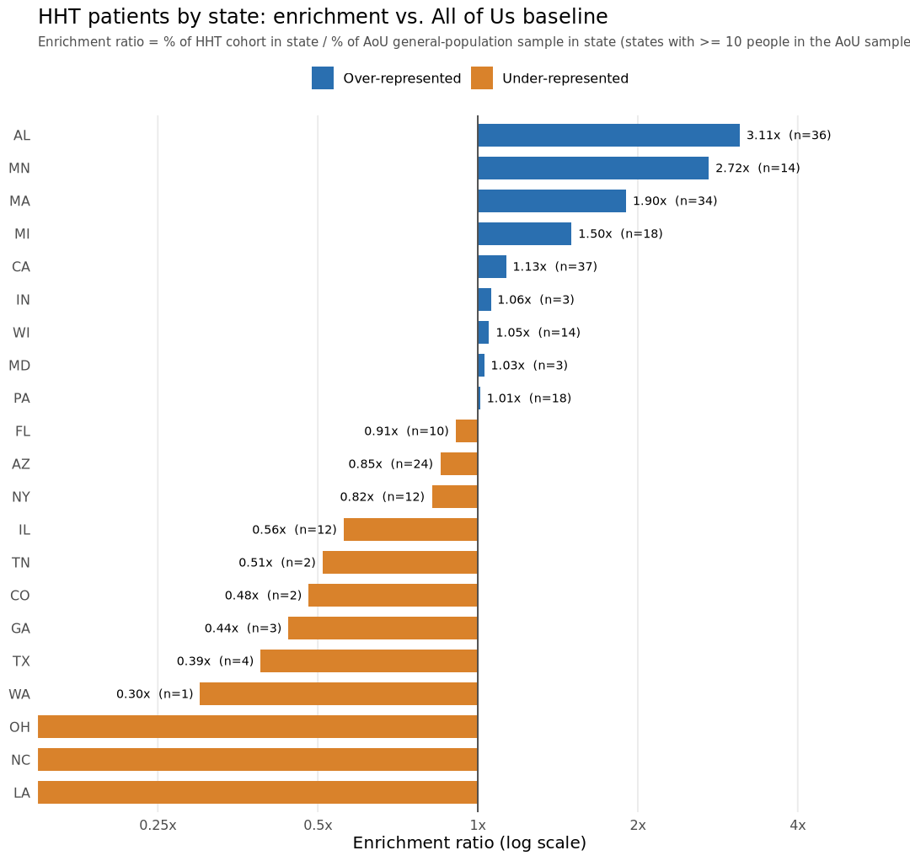
A random sample of 10,000 participants from the overall AoU cohort was taken and used as a baseline for comparison. The enrichment ratio (ER) was obtained by dividing the proportion of HHT patients living in that state by the proportion of the sample participants living in that state. States with fewer than 100 participants in the sample were excluded. Only Alabama was highest represented among HHT patients compared to controls, with an ER of 3.11 (n=36), followed by Minnesota (ER=2.72), Massachusetts (ER=1.90), Michigan (ER=1.50), and California (ER=1.13) (Figure __).

There are 28 HHT Centers of Excellence in the United States (Figure __).

Discussion
In this study, we found that the prevalence of diagnosed HHT in the All of Us database was approximately 1.74 in 5,000. The incidence peaked in the late 2010s at a rate of about 19 new diagnoses per year. Prominent HHT symptoms were first diagnosed when patients were in their 50s. Relative to the overall All of Us population, HHT-diagnosed patients were more concentrated in Alabama, Minnesota, Massachusetts, Michigan, and California.

There are several limitations of the current study. All of Us database is not perfectly representative of the U.S. population, as it highly depends on enrollment at specific sites. Patients with HHT might be disproportionately exposed to the medical system, or referred to the AoU Research Program by their providers. Due to the retrospective nature of the study and the inherent limitations of EMR and concept coding, many diagnoses are likely not being captured. For example, patients with diagnosed HHT had a 35.8% rate of epistaxis, whereas rates of upwards of 95% have been previously documented¹⁰.

Conclusion

1. Guttmacher AE, Marchuk DA, White RI, Jr. Hereditary hemorrhagic telangiectasia. N Engl J Med. Oct 5 1995;333(14):918-24. doi:10.1056/NEJM199510053331407
2. Shovlin CL. Hereditary haemorrhagic telangiectasia: pathophysiology, diagnosis and treatment. Blood Rev. Nov 2010;24(6):203-19. doi:10.1016/j.blre.2010.07.001
3. Kjeldsen AD, Vase P, Green A. Hereditary haemorrhagic telangiectasia: a population-based study of prevalence and mortality in Danish patients. J Intern Med. Jan 1999;245(1):31-9. doi:10.1046/j.1365-2796.1999.00398.x
4. Plauchu H, de Chadarevian JP, Bideau A, Robert JM. Age-related clinical profile of hereditary hemorrhagic telangiectasia in an epidemiologically recruited population. Am J Med Genet. Mar 1989;32(3):291-7. doi:10.1002/ajmg.1320320302
5. Dakeishi M, Shioya T, Wada Y, et al. Genetic epidemiology of hereditary hemorrhagic telangiectasia in a local community in the northern part of Japan. Hum Mutat. Feb 2002;19(2):140-8. doi:10.1002/humu.10026
6. Ferry AM, Wright AE, Baillargeon G, Kuo YF, Chaaban MR. Epidemiology and Trends of Hereditary Hemorrhagic Telangiectasia in the United States. Am J Rhinol Allergy. Mar 2020;34(2):230-237. doi:10.1177/1945892419886756
7. Donaldson JW, McKeever TM, Hall IP, Hubbard RB, Fogarty AW. The UK prevalence of hereditary haemorrhagic telangiectasia and its association with sex, socioeconomic status and region of residence: a population-based study. Thorax. Feb 2014;69(2):161-7. doi:10.1136/thoraxjnl-2013-203720
8. Anzell AR, C MW, Diergaarde B, Carlson JC, Roman BL. Hereditary Hemorrhagic Telangiectasia Prevalence Estimates Calculated From GnomAD Allele Frequencies of Predicted Pathogenic Variants in ENG and ACVRL1. Circ Genom Precis Med. Oct 2025;18(5):e005061. doi:10.1161/circgen.124.005061
9. Gaetani E, Giovannetti A, Di Martino L, et al. Global prevalence of hereditary hemorrhagic telangiectasia-associated variants estimated by analysis of large-scale genomic databases. J Thromb Haemost. Jan 27 2026;doi:10.1016/j.jtha.2025.12.025
10. Al-Samkari H, Friday C, Kasthuri RS, et al. Clinical spectrum of hereditary hemorrhagic telangiectasia: data from the Comprehensive HHT Outcomes Registry of the US (CHORUS). Blood. Jul 23 2026;148(4):417-432. doi:10.1182/blood.2026033112

